**Observations with 50 ns (e-cloud, instabilities) – very preliminary summary**

G. Arduini

Measurement data from: V. Baglin, G. Bregliozzi, P. Chiggiato, R. De Maria, J. M. Jimenez, G. Lanza, E. Métral, T. Pieloni, F. Roncarolo, G. Rumolo, B. Salvant, L. Tavian, OP

This is a very preliminary summary (my understanding) of the observations **performed by several colleagues** **(Accelerator Physics, Cryogenics, Operation, Vacuum)** and requires further analysis **and cross-checks with the teams involved in the measurements**. During the proton MD emphasis was given to the electron-cloud observations as this was observed to be a strong limitation in increasing the total intensity with the 50 ns beam and could be a serious limitation for operation next year. A quench test induced by a wire scan at 3.5 TeV of relevance for the UFO issue could be accommodated in the plan on Monday 1/11 from 10:00 to 19:00; the data are being analyzed by the MPP team.

**First observations (Sat 30/10 – Sun 31/10)**

Significant pressure rise difference between the first fill with 50 ns bunch spacing with 9 trains of 12 bunches each and the following fill with 50 ns bunch spacing when trains of 24 bunches started to be injected. The first attempt led to the closure of the vacuum valves in point 7 (VVGSH.774.6L7.R) due to pressure increase (interlock level: 10-7 mbar in two gauges) on the penning gauges VGPB.773.6L7.R on the (uncoated) cold-warm transition of the Q6L7.B2. **In that area beams circulate in different vacuum chambers.**

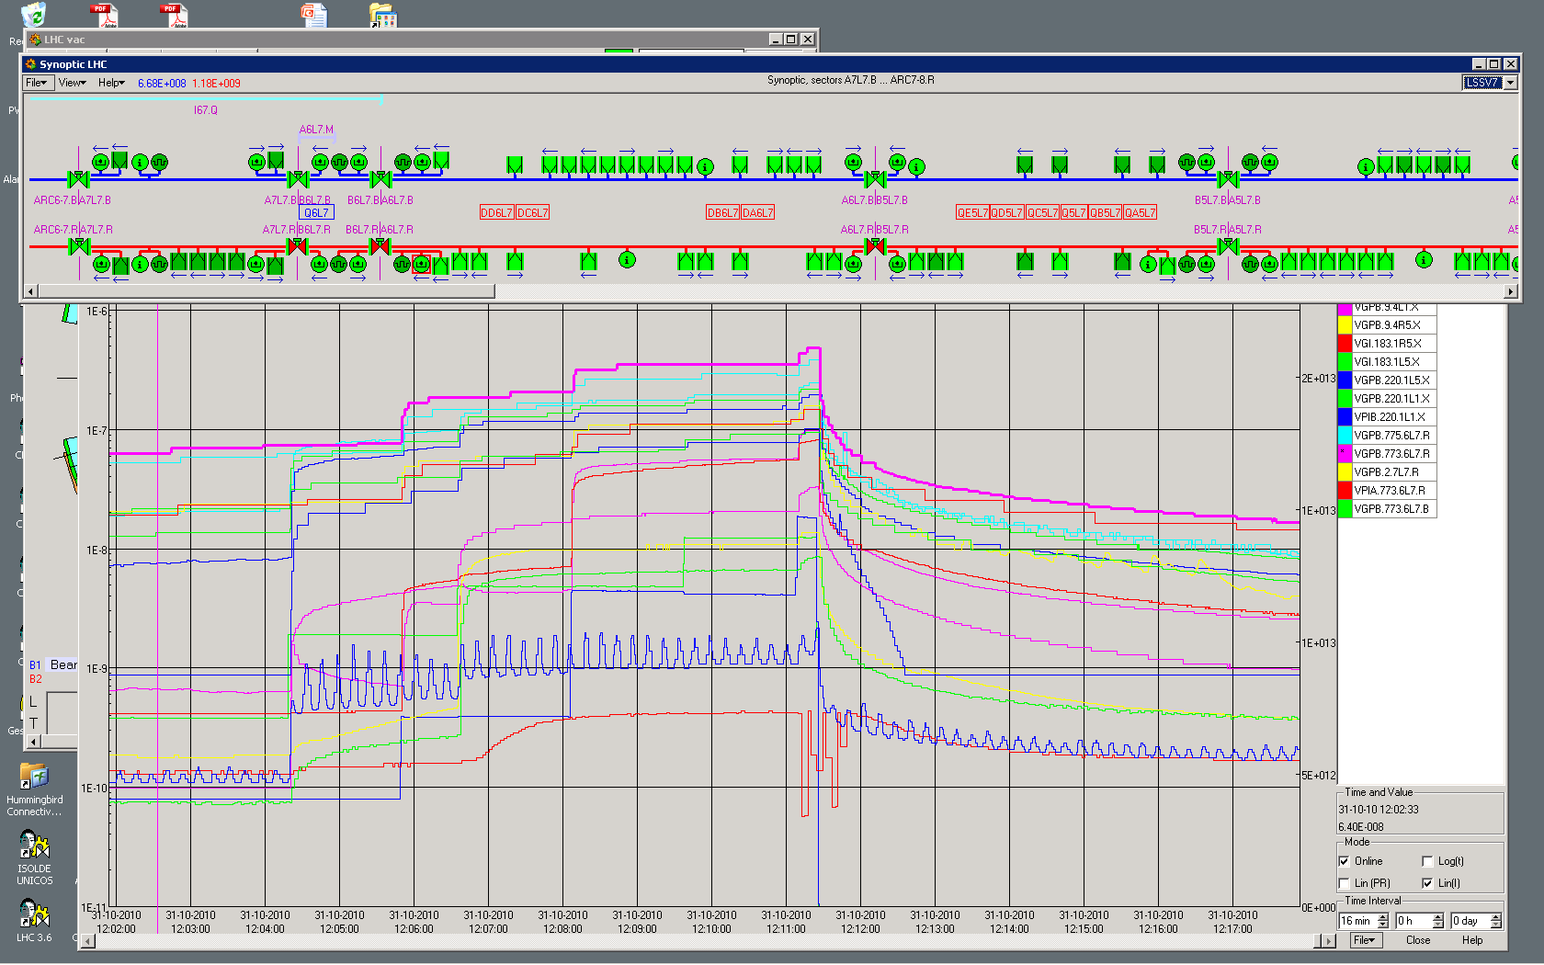

Fig. 1: pressure rise leading to vacuum valve closure on Sunday 31/10 at 12:11

Observed other locations where the pressure was getting close to 10-6 mbar. The highest pressure has been observed at VGPB.2.5L3.B (i.e. in LSS3 in the cold-warm transition near Q6 for Beam 1). This is close to the collimation area where seed electrons could be produced by losses.

In Fig. 2 the pressure rise for the 2 fills with 50 ns with 12 and 24 bunch trains are shown for three vacuum gauges. Pressures are shown in a logarithmic scale for VGPB.2.5L3.B (max pressure rise), VGI.461.6R2.R (warm-warm transition, NEG coating on both sides of the transition), VGPB.4.6R2.B (warm-cold transition, NEG coating only on the warm side of the transition).

Fig. 2: Pressures and total intensity for the first two fills with 50 ns spacing.

An even larger pressure rise was observed when injecting a train of 36 bunches after a train of 12 bunches as shown in Fig. 3 below.

All these indications are consistent with electron cloud build-up after >10 bunches along a 50 ns bunch train.

From the evolution of the pressure between the two consecutive fills with 12+24 bunches it can be observed that the “memory” of the conditioning is kept.

Fig. 3: Pressures and total intensity vs. time with bunch trains with different length. There was no beam between 23:00 and 03:00 because of a trip of Sector 78. The pressure rise at the start of the second fill with 12+2x24 bunches is the same as that at the end of the previous fill.

At 17:25 (UTC) the voltage on the RF cavities was increased from 4 to 7 MV to reduce the bunch length from ~1.3 to ~1.15 ns. No significant change in pressure was observed on the other hand the lifetime of the beam decreased particularly for B2, indicating that there is no strong dependence on bunch length. A reduction of the beam lifetime (but no evident coherent activity) has been observed in particular for beam 2.

**Electron Cloud measurement campaign Mon 1/11 19:00 – Tue 2/11 15:00**

The measurement campaign was aimed at determining the parameters of the electron cloud build-up from vacuum pressure data in the straight sections (in the uncoated parts) and from beam screen temperature data in the arcs to provide constraints for the simulations. Below the results for the vacuum pressure data are shown. Beam screen temperature data are being analyzed in order to get information for the arcs provided the sensitivity is sufficient.

*Measurement of the threshold for the onset of the electron cloud build-up in the straight sections from vacuum pressure measurements.* The trend is shown in Fig. 4 for the gauges already considered in the above plots. The vacuum pressure scale is logarithmic. The data have been taken by injecting always the same bunch pattern (12 + 36 bunches spaced by 35.7 microseconds).

Fig. 4: Vacuum pressures for different bunch populations for a constant filling pattern (12+36 bunches).

From the above we can say that the threshold for the onset of the build-up for the considered pattern is between 0.6 and 0.8x1011 p/bunch for the considered cold-warm transition and between 0.8 and 1.1 x1011 for the considered warm-warm transition.

*Measurement of the electron cloud build-up vs. number of bunches.* 3 different bunch train configurations have been injected 12+12 bunches, 12+24 bunches and 12+36 bunches, The distance between the two trains of 12 bunches and nx12 bunches (n=1,...,3) was 35.7 microseconds. The pressure rise in the vacuum gauges previously considered is plotted in fig 5 (log scale) together with the total beam intensity. This indicates that no significant electron cloud build-up occurs in the first 12 bunches as no visible pressure rise is observed for 12+12 bunches.

Fig. 5: Vacuum pressures vs. number of bunches in the train for nominal bunch intensity.

Fig. 6 show the pressure rise dependence vs. spacing between 2 trains of 24 bunches for the vacuum gauge featuring largest pressure rise. The “memory” of the electron cloud build-up for this configuration is lost after more than 7.5 microseconds.



Fig. 6: Pressure rise vs. spacing between two trains of 24 bunches with nominal bunch intensity.

**Scrubbing test - Tue 2/11 15:00 – Wed 3/11 20:00 and ramp to 3.5 TeV (Wed 3/11 20:00 – Thu 4/11 08:00)**

This period has been used to study the evolution of the pressure rise in the straight sections and of the beam screen temperature (still to be analyzed) vs. time. During this period trains of 24 bunches have been progressively injected in order to keep the vacuum pressure in the straight sections as close as possible to the interlock level (which has been temporarily increased from 4x10-7 mbar to 10-6 mbar in few sections showing the largest pressure rise).

In parallel bunch-by-bunch emittance measurements have been performed with the synchrotron light monitor along the bunch trains in order to gain additional information about the electron cloud instabilities along the bunch trains and to test the effect of parameters like chromaticity and transverse emittance of the injected beam on beam stability as input for possible scrubbing scenarios.

A ramp with 108 bunches (1x12 + 4x24 bunches) per beam has been performed at the end of the scrubbing period in order to qualify the vacuum and heat load evolution with energy for this bunch train configuration and to conduct beam-beam studies at 3.5 TeV with maximum number of parasitic collisions. Two ramps were performed. The first one failed at 1.5 TeV due to a collimator position reading error while the second succeeded but the beams were damped by beam losses at flat-top when the transverse feedback was switched off before starting the squeeze (standard operational procedure).

The evolution of the pressure at the selected vacuum gauges is shown in Fig 7 together with the beam intensity evolution.

Fig. 7: Pressure evolution and beam intensity during the scrubbing test.

In order to qualify the improvement on vacuum as a result of the scrubbing the vacuum rise for a train of 12+36 bunches has been measured and compared with that observed on Sunday 31/10.

The comparison is shown in Fig. 8. A reduction of the pressures by a factor close to 10 has been observed.

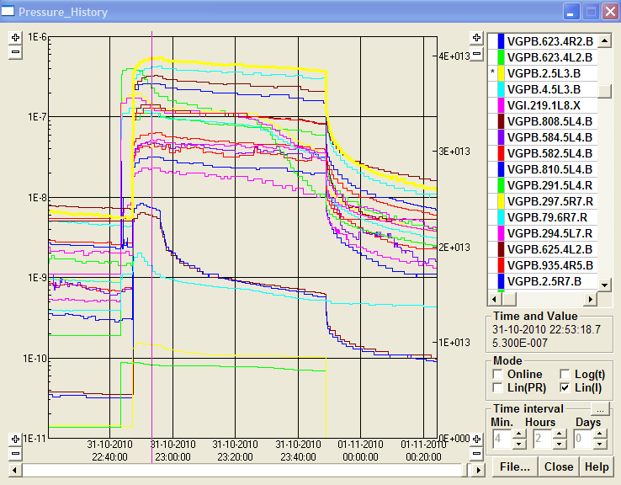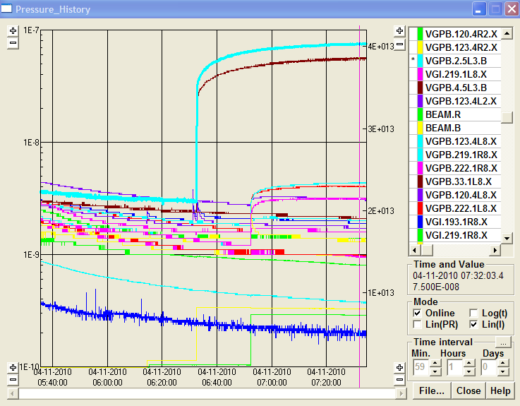

Fig. 8. Vacuum pressures before the scrubbing test (left) and after (right). The evolution of the vacuum pressure on the vacuum gauge showing the maximum pressure rise (VGPB.2.5L3.B) is highlighted (yellow curve on the left plot and light blue curve on the right plot). Note the different scale. Courtesy G. Bregliozzi.

The heat load for on the beam screen measured on cell 33L6 (Qadd) is larger than the value expected from losses due to synchrotron radiation and image currents (Qtot) and it is shown in Fig. 9 before the scrubbing test (30/10-left) and after the scrubbing test (4/11-right) for the same number of bunches. On 30/10 the filling pattern consisted of 9 trains of 12 bunches each and on 4/11 the filling pattern was: 1x12 + 4x24 bunches. There seems to be a reduction of the heat load at injection energy after the scrubbing test but the reduction of the heat load during the ramp is not evident taken into account that on 4/11 the beam was dumped before the temperature on the beam screen could stabilize. This could be related to the more unfavourable (form the point of view of the electron cloud build-up) filling pattern (with trains of 24 bunches) used on 4/11.



Fig. 9. Heat loads for two ramps to 3.5 TeV before (left) and after (right) the scrubbing test (Courtesy L. Tavian).

The observed additional heat load corresponds to ~40 mW/m per aperture (simulations are being launched in order to benchmark the model and determine the expected value of the SEY) which appears to be significantly larger than expected for the considered number of bunches.

It must be noted that for the 150 ns beam (with 104 bunches) the measured beam induced heat load was consistent with the expectations taking into account the power dissipated by synchrotron radiation and image currents as shown in Fig 10. This means that there is no evidence for electron cloud build-up in the arcs for the 150 ns beam with the filling pattern used with 104 bunches.



Fill#1375

Fill#1373

Fill#1372

Fig. 10. Heat loads during operation with 150 ns spacing beam and 104 bunches (Courtesy L. Tavian).

An increase in vacuum pressure is observed during the ramp at the location selected as reference for the measurements. This is not correlated with the reduction in bunch length. It occurs between 1.5 and 2 TeV and could be therefore correlated with synchrotron radiation. This could also explain the increase of the heat load in the arcs (shown in Fig. 9) resulting from multipacting triggered by photo-electrons. (see Fig. 11).

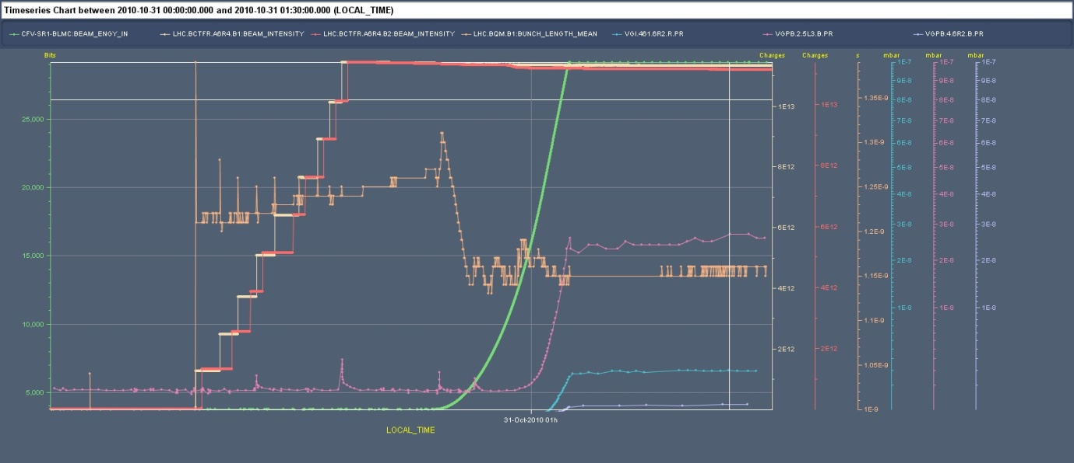

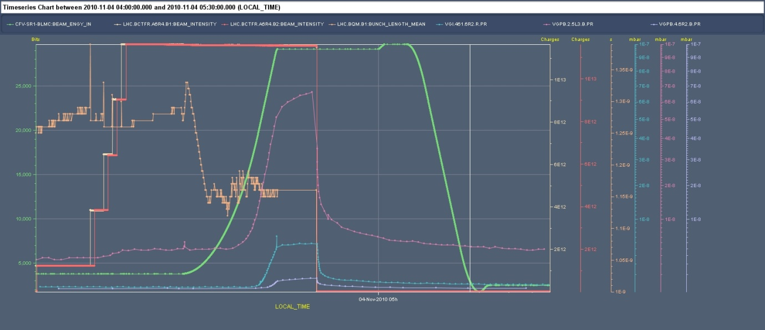

Fig. 11 Vacuum pressure evolution for the ramps performed on 31/10 (top) and 4/11 (bottom) with 50 ns beam and 108 bunches.

For comparison, the same vacuum pressure evolution is observed for 150 ns spacing with similar beam intensity (104 bunches instead of 108) (Fig. 12)

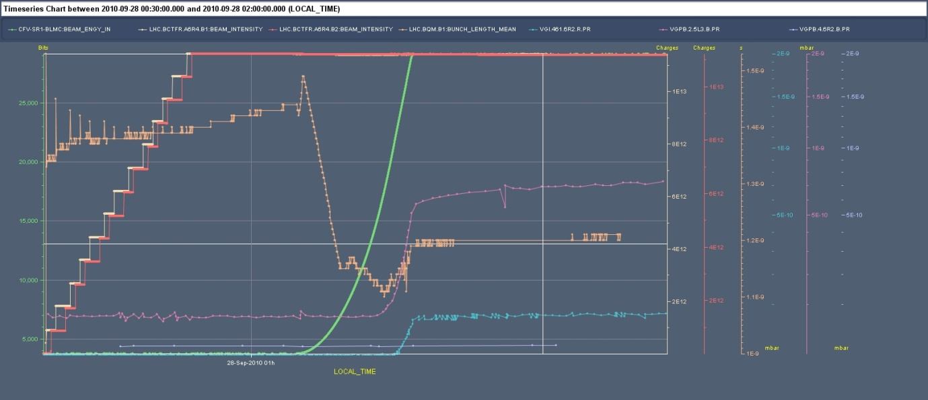

Fig. 12 Vacuum pressure evolution for the ramps performed on 28/9 with 150 ns beam and 104 bunches. It must be noted that the maximum of the pressure scale is 2x10-9 mbar (almost two orders of magnitude lower than in the above plot).

**Beam stability studies (conducted in parallel to the vacuum and heat load measurements).**

Bunch-by-bunch measurements of the emittance evolution during the scrubbing run have been performed. The beam emittance has been measured sequentially along the trains.

In Fig. 13 the emittance evolution along a bunch train of 36 bunches (injected after a train of 12 bunches with a spacing of 35.7 microseconds) is shown. The measurement was taken on 1/11 between 21:30 and 23:00. The measured emittance is an average over 1.5 hours and the error bars represent the r.m.s. of the emittance values for a give bunch measured over this interval of time and are therefore an indication of the variation of the emittance during this period. Small error bars indicate that there is little emittance evolution during the considered period and blow-up occurs very close to injection (the possibility that blow-up occurs already in the injectors has been excluded later). There is a clear blow-up of the emittance along the train starting in the second half of the train. This is compatible with the observations on the dependence of the pressure rise as a function of the bunch train length presented above. The fine structure should be more carefully analyzed taken into account losses that were observed during the fill. These measurements were taken with “standard” machine settings (damper gains close to maximum, chromaticity of 4 units in both planes).

 

Fig. 13 Emittance evolution along a bunch train of 36 bunches for Beam 1 and Beam 2. (Courtesy F. Roncarolo).

The average of the values of the emittance over a period of 1.5 hours measured on 2/11 from 15:50 to 17:30 are shown in Fig. 14 for the case of 4 trains of 24 bunches. This behaviour is consistent with the observation that the time to reset the electron cloud after a bunch train passage is larger than the batch spacing (in this case 1.85 microseconds) as mentioned above. These measurements were taken with “standard” machine settings (damper gains close to maximum, chromaticity of 4 units in both planes).

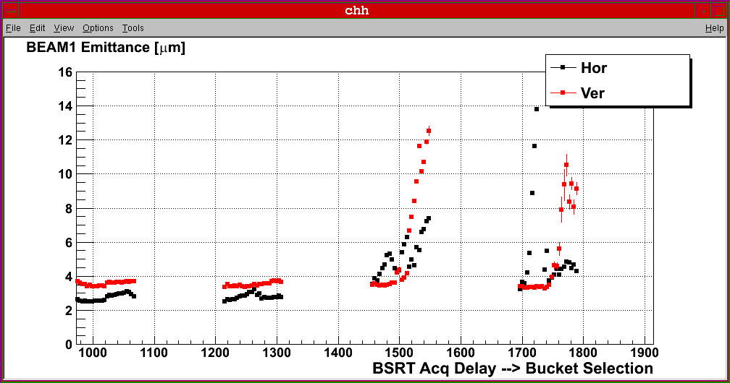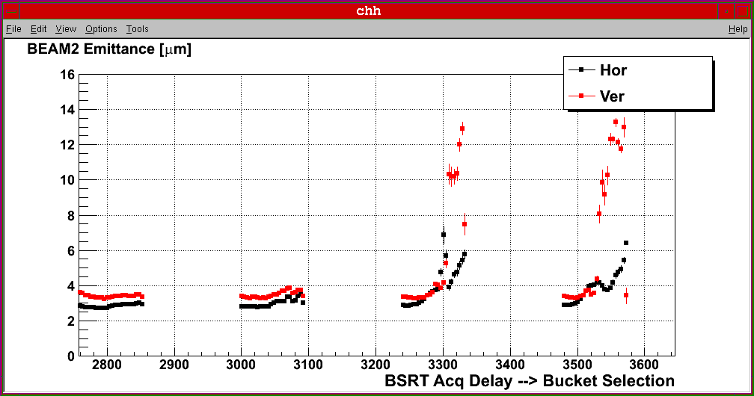

Fig. 14. Emittance evolution along a bunch train of 1x12 + 4x24 bunches (spaced by 1.85 microseconds) during the scrubbing test. Only the 4 trains of 24 bunches are shown. (Courtesy F. Roncarolo).

The effect of chromaticity and larger injected emittance has been studied as a possible mean to increase the number of bunches during scrubbing while minimizing the effect of beam instability and losses which can limit the efficiency of the scrubbing process.

Chromaticity has been increased up to 18 units and controlled transverse emittance blow-up in the injectors has been performed to increase the transverse emittance from 2-2.5 micrometers to 3-3.5 micrometers. The results of these tests are shown in Fig. 15 and Fig. 16 respectively.

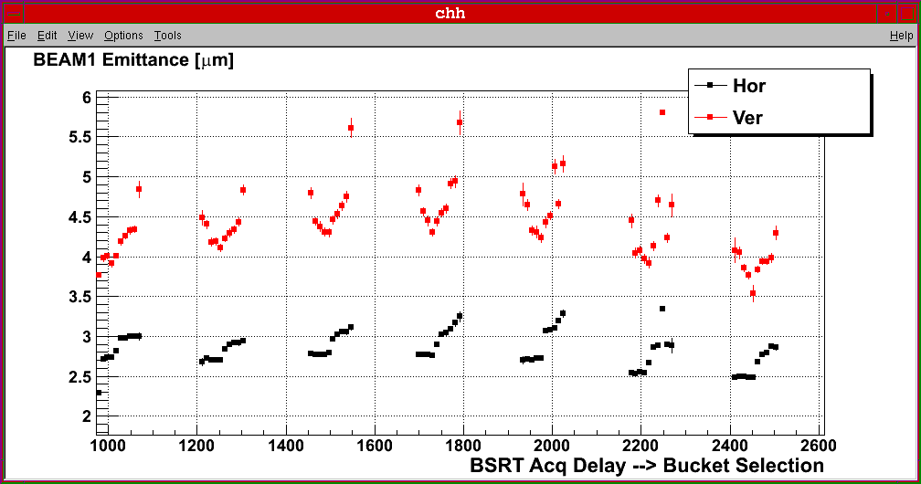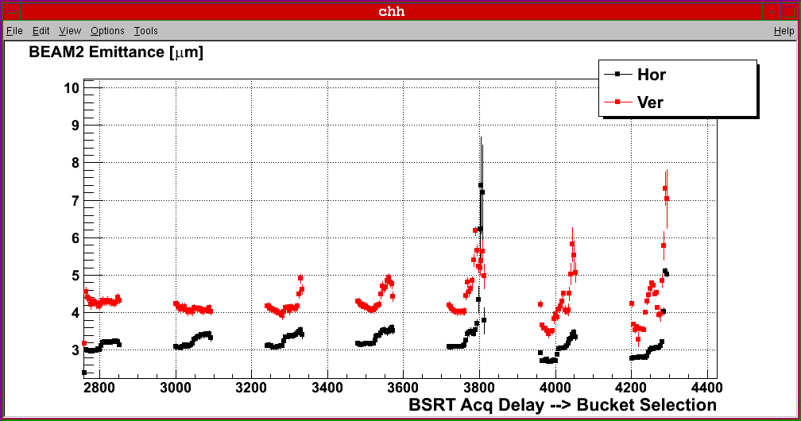

Fig. 15. Emittance evolution along a bunch train of 1x12 + 7x24 bunches (spaced by 1.85 microseconds) during the scrubbing test. Chromaticity was set to 14 units in both planes. Only the 7 trains of 24 bunches are shown. (Courtesy F. Roncarolo).

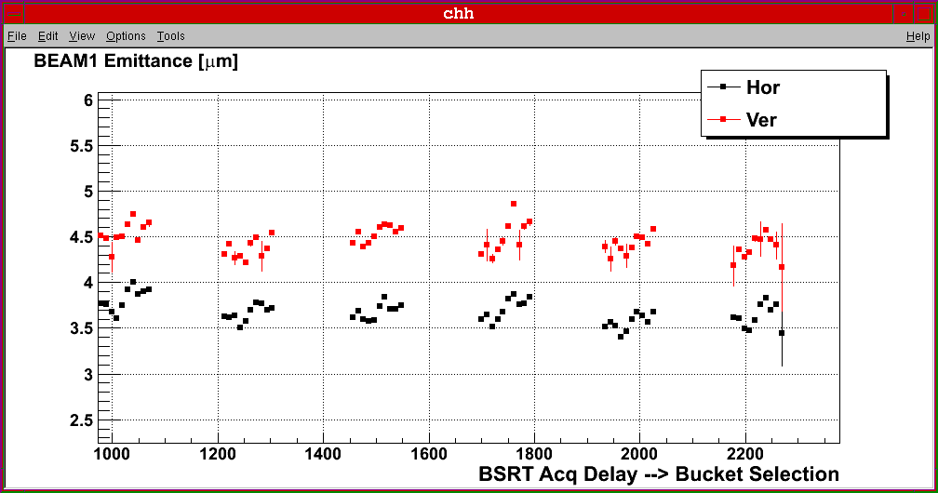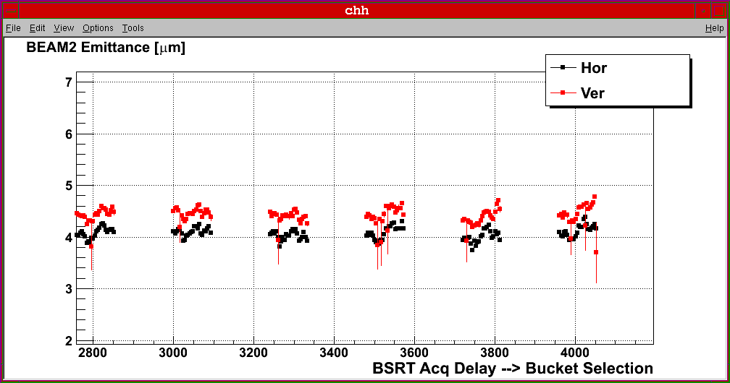

Fig. 16. Emittance evolution along a bunch train of 1x12 + 6x24 bunches (spaced by 1.85 microseconds) during the scrubbing test. Chromaticity was set to 18 units in both planes and transverse emittance blow-up was applied in the injectors. Only the 6 trains of 24 bunches are shown. (Courtesy F. Roncarolo).

Chromaticity and transverse emittance blow-up are effective in stabilizing the beam and minimize emittance blow-up along the bunch trains in the presence of electron clouds as already observed in the SPS.

The characteristics of the instability observed at injection with the transverse feedback ON and at flat-top after switching off the damper are being analyzed more in detail.

At injection operation with large chromaticity seem to be required even for large gains of the transverse feedback pointing to single bunch instabilities at frequencies outside the bandwidth of the feedback as observed in the SPS.

At flat-top the instability has been observed when bunch trains of 24 bunches have been used instead of trains of 12 bunches (the total number of bunches was the same: 108) with the same settings (tune, chromaticity, octupoles strength). The transverse feedback is sufficient to stabilize the beam but that requires running with the feedback ON during the squeeze and the compatibility issues with the tune feedback must be addressed as already done for the ramp.

The evolution of the amplitude of oscillation of the beam at flat-top as measured by the BBQ system is shown in Fig. 17. The rise time of the oscillations have been determined to be: B1H=0.2-1.2 s, B2H=0.7-1.5 s and B1V=1.1 s, B2V=2 s.

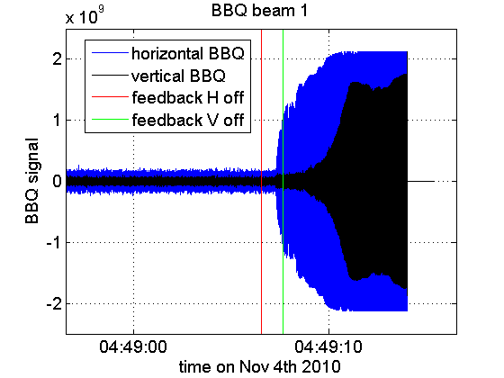 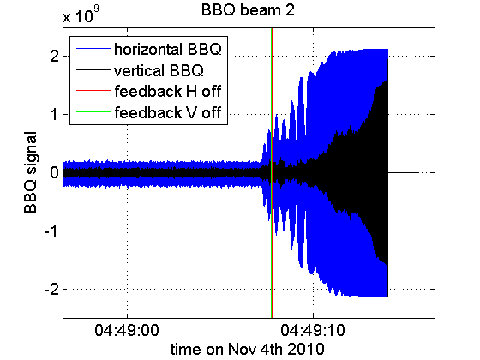

Fig. 17: Amplitude of oscillation of the beam at 3.5 TeV when the transverse feedback is switched OFF as measured by the BBQ system for Beam 1 (left) and Beam 2 (right). The logged time of the transverse feedback switch OFF is not precise to better than 1 second (Courtesy of H. Bartosik and B. Salvant).

**Some very preliminary conclusions and proposals for next steps**

With 50 ns spacing electron cloud build-up is occurring in the in the uncoated sections even in areas where the two beams circulate in different pipes and even for few short trains (longer than 12 bunches). The pressure rise in uncoated cold-warm transitions seems to be larger than in warm-warm transitions where NEG coating is present on both sides of the uncoated transition. In these areas solenoidal fields (as proven by the experience made by the VSC Group) are effective to suppress electron-cloud (but at the same time prevent scrubbing). Scrubbing seems to be effective in these areas with a reduction of the pressure rise by a factor 10 after about 1 day of operation with beam.

More worrying is the situation in the arcs where evidence of significant heat load due to electron cloud has been collected. The heat load data presented are very preliminary and need confirmation. Scrubbing at 450 GeV seems to reduce the heat load due to electron cloud measured at injection but evidence for its reduction during the ramp and at high energy has not been obtained univocally.

The experiments conducted should be sufficient to provide input for simulations at least in the straight sections and possibly in the arcs (pending the final analysis of the beam screen temperature data) and allow extrapolations.

Data on the observed instabilities (whose characteristics strongly depend on the electron cloud characteristics in the arcs) have been collected although we suffered from the lack of operational bunch-by-bunch diagnostics (with few exceptions).

More data are needed to confirm the effectiveness at high energy of the 450 GeV/c scrubbing in the arcs. In particular a ramp to 3.5 TeV (no squeeze needed) with the same filling pattern used for the physics fill on 31/10 (9 x 12 bunches) can clarify the effect of the short scrubbing test performed and allow making projections for operation in 2011.

The evaluation of the behaviour with 75 ns beams at 450 GeV and comparison with the 50 ns beam, both in terms of pressure-rise and (possibly) heat load as well as in terms of beam stability is necessary to complete the information required for defining the running scenarios for next year.

The stop for ion physics for the re-fill of the ions source oven could be used to perform part of these tests.