**Question that we should try to answer and simulations for Electron Cloud build-up and ECI at the LHC for Chamonix (my understanding - for discussion)**

List of parameters to be provided at the output of the simulation:

* Central electron density
* Average electron density
* Average Number of electrons hitting the wall/bunch
* Energy distribution of the electrons
* Average Heat load/bunch

Simulations (proposed order of decreasing priority):

* What are the SEY and R parameters that best fit the observations with 50 ns before scrubbing (vacuum in the straight sections - VGPB.2.5L3.B - at 450 GeV and Heat Load in the arcs at 3.5 TeV)? (see attached note for the vacuum measurement results and beam conditions from **Mon 1/11 19:00 – Tue 2/11 15:00**). The heat load was measured at 3.5 TeV with 108 bunches (+ 1 pilot in bucket 1) with 50 ns spacing according to the filling scheme below (bunch intensity was 1x10^11 p/bunch):

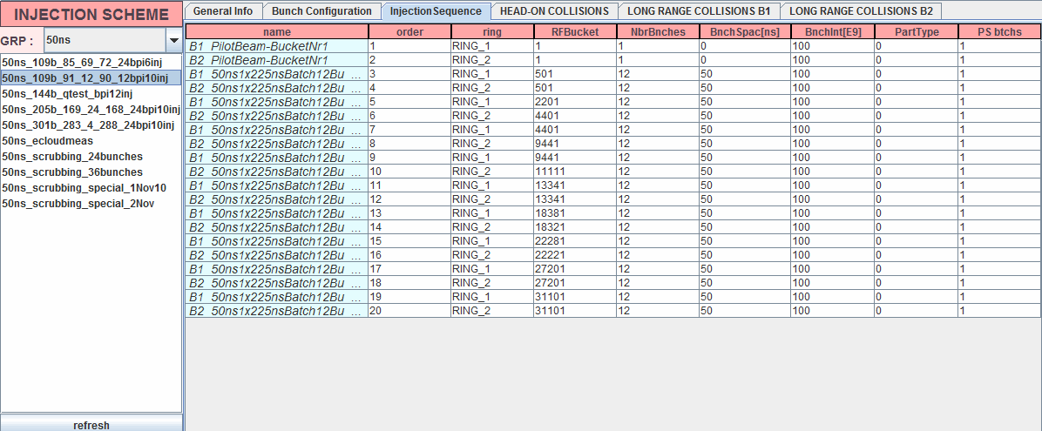

The measured heat load (after subtraction of image currents and synch light) is shown below (Picture from Laurent Tavian) with a peak of 20 mW/m/beam



* For the above parameters (SEY and R) what is the scaling for e-cloud build-up with beam size and bunch length at 450 GeV in the arcs and in the straight sections (worst case i.e. VGPB.2.5L3.B)? What happens if we reduce the SEY? 🡺 This is to define our scrubbing procedure.
* Is the position of the stripes in the arcs very sensitive bunch population at injection? How does it vary going from 1.1 to 1.5 x 1011 p?
* What is the maximum SEY we can accept for the 75 ns beam to avoid any blow-up at 450 GeV? and at 3.5 TeV? and at 4 TeV? All that assuming that we have reduction of the SEY in the regions scrubbed at 450 GeV (so where we have the stripes for example).
* How sensitive are we to the beam position in the straight sections, quadrupoles and D1 assuming that we have scrubbed certain regions at 450 GeV?
* What is the SEY after the scrubbing run taken into account the reduction of the Heat Load at 3.5 TeV and of the pressure rise at 450 GeV and at 3.5 TeV with 50 ns? As a reference for the measurements We could take the behaviour at 450 GeV and 3.5 TeV for the same filling pattern as above (108 bunches of 1x1011 p + 1 pilot – only Beam 2). The measured heat load is shown below (less than 10 mW/m/beam).
* 

And this is the vacuum pressure (including VGPB.2.5L3.B)

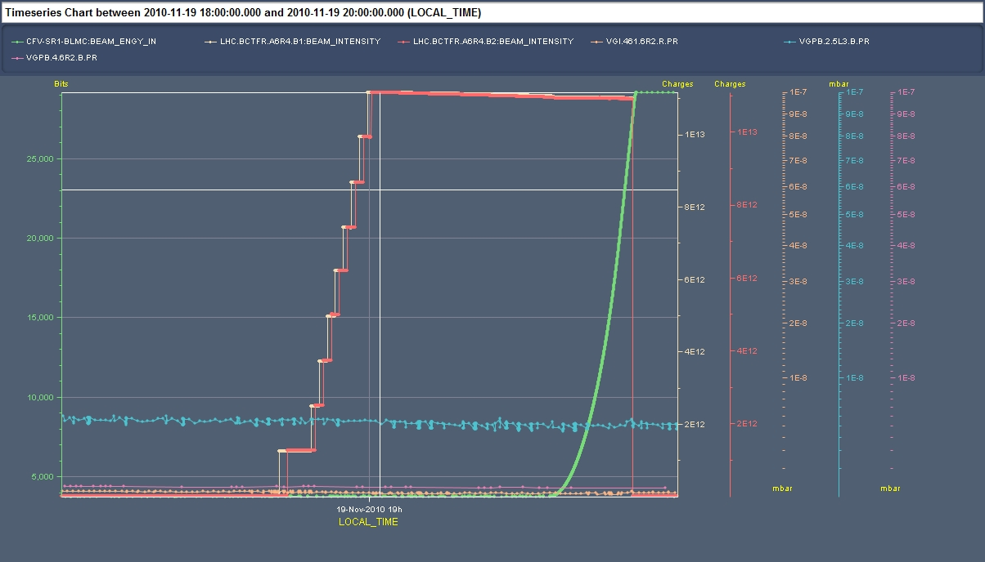

* With this lower SEY after scrubbing run can we explain the observations done with 75 ns with multi-bunch? I.e.: no heat load in the arcs (on top of those expected from image current) at 450 GeV and pressure rise for 680 bunches per beam as shown below (usual gauge)

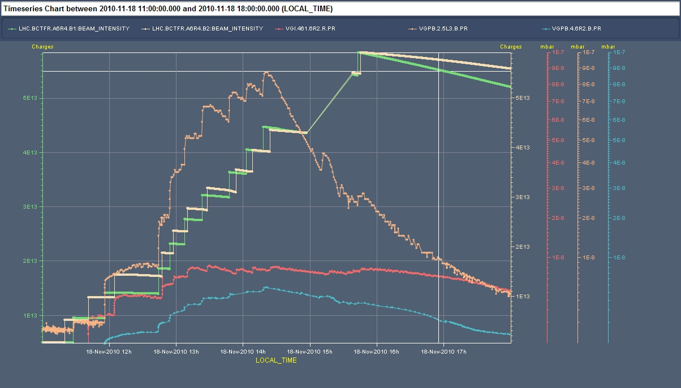

The filling pattern is indicated below (each train of 48 bunches is composed by 2 trains of 24 bunches each and spaced by 225 ns. The bunch population was 9x1010 p).

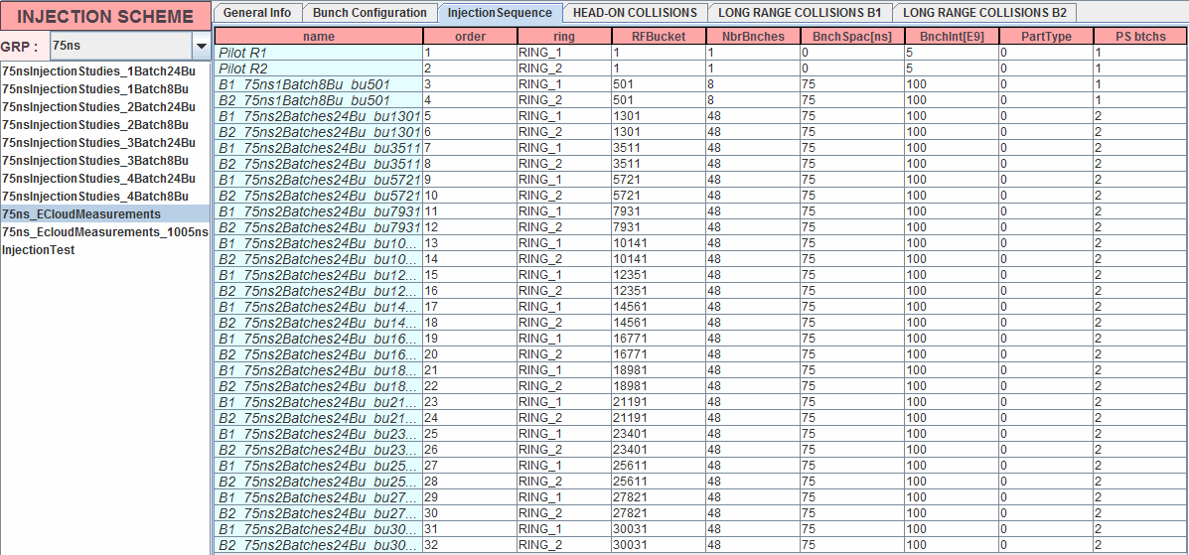

* Can we introduce the desorption yield in the simulations and simulate the pressure rise?
* How does the e-cloud build-up and ECI scale with bunch spacing if we keep the total intensity constant? We assume that the emittance is constant (for the PSB this should be the case). What is the situation if we keep luminosity constant. I.e. increasing of the spacing by a factor 2 and of the bunch intensity by sqrt(2) at constant brightness?